C.V
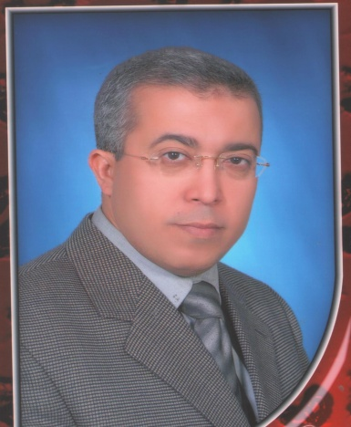
Dr / KHALED ABDEL AZIZ MAHMOUD
Over 35 weeks of offshore training, seminars and quality surveillance for in USA, JAPAN, and UK

Several training programs have been implemented, more than 200 courses, to great institutions such as ADNOC, Aramco, GASCO, Kuwait KPC, NOMAC, TAKREER Refinery Ruwais UAE, VEOILIA OMAN, DEWA,SEWA, Kuwait KOC……..

- I received a prestigious award from sharjah government year 2008
-Name: Khaled abed Aziz Mahmoud
Nationality: Egyptian
Civil Status: Married
Religion: Moslem
Date of birth: 16 April 1964.
Mobile number :
Mobile number in Egypt: 00201143941540
:0097150191617

E-Mail: khaledaziz81@hotmail.com
Education:
1- Bachelor in mechanical engineering, 1989.
Faculty of engineering. Shoubra – Cairo
Zagazic University, Cairo
2- Master degree in Mechanical engineering, 1993
Fault analysis for gas turbine generator.
Faculty of engineering. Shoubra – Cairo
Zagazic University, Cairo
2- PhD in Mechanical engineering, ‏2004
Transient spread of Fires
Faculty of engineering. Shoubra – Cairo
Zagazic University, Cairo
OFFSHORE TRAINING:
Over 35 weeks of offshore training, seminars and quality surveillance for design, erection, operation and maintenance of gas turbine and steam turbine power plants in USA, JAPAN, and UK
And how to making a training course to new graduate by latest technique in the field of power generation. And other courses.

Personal Details
Dr. khaled abdel aziz , PhD., is an International Expert in Mechanical Maintenance Engineer with over 29 years of Industrial Experience in Gas turbines, steam turbines, Combined cycles, Pumps, compressors, valves, mechanical seal, Shaft Alignment and Maintenance Planning and Condition Monitoring, Vibration Measurements and Analysis, Balancing,, Computer Maintenance Management System, troubleshooting, maintenance planning and scheduling.
Dr khaled abdel aziz was given as well as prestigious award from Sharjah government (UAE) for his hard work, vision administrate and modifications to improve efficiency
Dr. khaled abdel aziz was the head of mechanical engineering and maintenance department in Sharjah electricity and water authority
whose main responsibility is to be principle consultant for the modification and upgrading with conducting and preparing course materials for engineers to improve the efficiency in terms of cost and ensure safe operation for all rotating equipments
He had over 20 years of direct experience in projects, operation, maintenance, safety and training.
He started his career as a shift charge engineer in Egyptian electricity authority cairo and after couple of years in operation and maintenance section he became a manager for mechanical maintenance department after showcasing high performance in the job.
Dr khaled working now as technical advisor for many companies in gulf area ( oil, gas companies and power stations).
He delivered many courses covering the area of design, operation, maintenance and troubleshooting of gas turbine, steam turbine, combined cycles power stations, compressors, pump etc.
Dr. khaled is a certified member in National Fire Protection Association and safety (NFPA), USA. Also He is a certified member in NASP ( national association of safety professional) number 509581.
Because he had a diploma in management from UK in 2000 he delivered many courses coverage the topics of maintenance management, preventive maintenance and scheduling.
He had 30 weeks of offshore training , seminars and quality surveillance for design, operation, maintenance of rotating equipment ( gas turbine & power station) , fire fighting systems and safety topics this training from USA, JAPAN, UK .
Dr khaled is a member of engineering society and member of society, federation of Arab engineers, member of Society of Mechanical Engineers also he Member of the International Jury. He is author & Co-author of many papers published is international journals and conferences.
CHORNOLOGICAL EXPERIENCE RECORD:
Dates : 8/2/2016 till now
Misr University For Science and Technology
Professor at faculty of engineering (part time) Egyptian electricity authority

Job Title : General manager of Technical Affairs Department.
6 October power station
Level of responsibility:

- Monitor, analyze and improve system performance.
- Calculate and study the system demand every day .
- Manage the process for all of the operation / maintenance section with high efficiency. Conduct technical monitoring, analysis, evaluation and investigation of plant's operation.
- Formulate plans arrangements and recommend the most reliable and economical alternative to alternative system problems.
- Manage the process for all of the operation / maintenance section with high efficiency. Conduct technical monitoring, analysis, evaluation and investigation of plant's operation.
- preparing all planning of preventive maintenance and all others of all types of maintenance.
- study all problems for all power station which occur every day and solving it by arranging with other departments.
CHORNOLOGICAL EXPERIENCE RECORD:
Dates : 2012 to 7/2/2016
Egyptian electricity authority

Job Title : Director of Technical Affairs Department.
Level of responsibility:
Consultant for the modification and upgrading with conducting to improve the efficiency in terms of cost and ensures safe
- Manage the process for all of the operation / maintenance section with high efficiency. Conduct technical monitoring, analysis, evaluation and investigation of plant's operation.
- Monitor, analyze and improve system performance.
- Preparing and presenting courses.

- Manage the process for all of the operation / maintenance section with high efficiency. Conduct technical monitoring, analysis, evaluation and investigation of plant's operation.
- Formulate plans arrangements and recommend the most reliable and economical alternative to alternative system problems.
- Assist production units in resolution of equipments and system problems and requested.
- Preparing all monthly, yearly report for calculation the efficiency and other parameter for all the plant as a technical affairs.
- Making all test for all the unit such as changeover to liquid fuel , all switches to keep all unit as a standby at any time.
CHORNOLOGICAL EXPERIENCE RECORD:
Dates : 2009 to 2012 Now
DEWA (DUBAI ELECTRICITY & WATER AUTHORITY)

Job Title : Dupty Manager of planning, performance and reporting department
Job description / Technical advisor
Level of responsibility:
Consultant for the modification and upgrading with conducting and preparing the courses material for the different clients (engineers, operators, supervisors and technicians) to improve the efficiency in terms of cost and ensures safe
- Manage the process for all of the operation / maintenance section with high efficiency. Conduct technical monitoring, analysis, evaluation and investigation of plant's operation.
Monitor, analyze and improve system performance.
- Calculate and study the system demand every day .
- Manage the process for all of the operation / maintenance section with high efficiency. Conduct technical monitoring, analysis, evaluation and investigation of plant's operation.
- Formulate plans arrangements and recommend the most reliable and economical alternative to alternative system problems.
- Manage the process for all of the operation / maintenance section with high efficiency. Conduct technical monitoring, analysis, evaluation and investigation of plant's operation.
- Assist production units in resolution of equipments and system problems and requested.
- Preparing all monthly, yearly report for calculation the efficiency and other parameter for all the plant as a technical affairs.
- Making all test for all the unit such as changeover to liquid fuel , all switches to keep all unit as a standby at any time.

CHORNOLOGICAL EXPERIENCE RECORD:
Dates : 2004 to 2009
Employer : SEWA (sharjah electricity and water authority) UAE
Job Title : Operation and Maintenance head section
Job description /
Level of responsibility:
-As per my designation with extra responsibility of principle consultant for the modification and upgrading for all rotating equipment compressors, pumps and all types of power station with conducting and preparing the courses material for the engineers, operators, supervisors and technicians to improve the efficiency in terms of cost and ensures safe operation of the power & Desalination Plants under SEWA.
- Manage the process for all of the operation / maintenance section with high efficiency. Conduct technical monitoring, analysis, evaluation and investigation of plant's operation.
- Preventive and corrective maintenance of various types of gas turbine, steam turbines, HRSG, rotating and static equipment.
- Troubleshooting and failure analysis of pumps, compressors, diesel engines and fan coolers.
- Condition monitoring of rotating equipment to ensure the availability and reliability.
- Maintenance of static equipment such as, heat exchangers, pressure vessels (e.g. expansion drums), tanks and separators.
- Maintenance and installation of piping systems with all related fittings and valves.
- Mechanical Equipment Installation as per International Standards.
- Capable of preparing contract specifications, scope of works and tenders evaluation.
- Capable of preparing list of spare parts, issuing material requisitions, evaluating the quotations till awarding as well as checking the received materials.
- Throughout the years of involvement in maintenance of Oil and Gas plants, I have attended numerous numbers of Technical Training and HSE awareness Programs.
Throughout the years of my career I have conducted several in-house and public training courses in different Arab Countries which are certified by IACET (International Association for Continuous Education and Training)

- Monitor, analyze and improve system performance.
- Preparing and presenting courses.

Dates : 1998 -2004
Employer : Egyptian Electricity Authority
Job Title : Mechanical Maintenance Department Head
Job description /
Level of responsibility:
- Manage the process for all of the operation / maintenance section with high efficiency. Conduct technical monitoring, analysis, evaluation and investigation of plant's operation.
- Preventive and corrective maintenance of various types of gas turbine, steam turbines, HRSG, rotating and static equipment.
- Troubleshooting and failure analysis of pumps, compressors, diesel engines and fan coolers.
- Condition monitoring of rotating equipment to ensure the availability and reliability.
- Maintenance of static equipment such as, heat exchangers, pressure vessels (e.g. expansion drums), tanks and separators.
- Maintenance and installation of piping systems with all related fittings and valves.
- Mechanical Equipment Installation as per International Standards.
- Capable of preparing contract specifications, scope of works and tenders evaluation.
- Capable of preparing list of spare parts, issuing material requisitions, evaluating the quotations till awarding as well as checking the received materials.
- Throughout the years of involvement in maintenance of Oil and Gas plants, I have attended numerous numbers of Technical Training and HSE awareness Programs.
Prestigious award
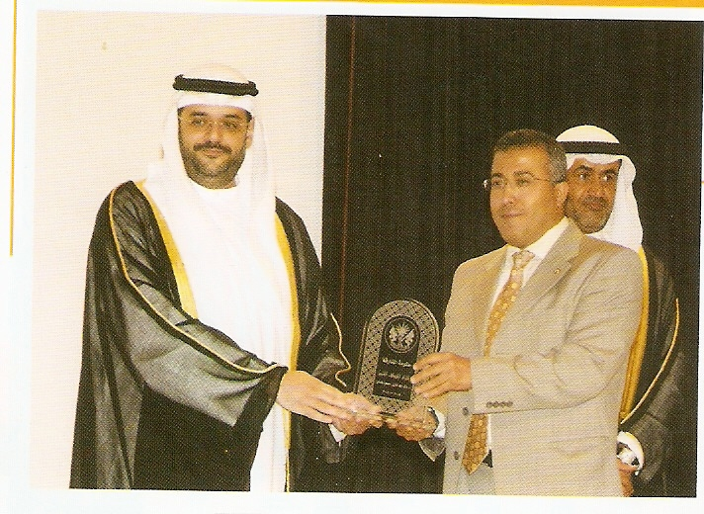
For my hard work, vision administrate and modification to improve the efficiency for (power & water ) and gas stations plant I received a prestigious award from sharjah government the distinguished employee award in the government of sharjah 2008

Dates : 1993 -1998
Employer : EEA Cairo South power station / Bechtel company
Job Title : Mechanical start up engineer
Job description /- Head of the members of the performance tests cast proceeds by E.E.A.(Egyptian electricity authority).
- Head of the members of the development technical affairs team proceeded by E.E.A.

Level of responsibility:
Assigned as consultant to GTCC/Bechtel , A joint venture between overseas bechtel Inc. and Gilbert commonwealth International Inc. at their Cairo south power station 150 MW combined cycle project .At this project my responsibility included monitoring the day to day activities of contractors mechanical start up organization coordinating the daily interface between the contractor and the EEA during the checkout, preoperational testing and cleaning of the mechanical systems and equipment ; witnessing the mechanical static, directly involved in the commissioning of all plant systems.
Dates : 1989 -1993
Employer : EEA Cairo South power station
Job Title : Shift charge engineer
Job description /
Level of responsibility:
Responsible for operation & maintenance of three G.E frame 9,110Mw Industrial gas turbine and generators with G.E mark IV,Turbine control system.
Responsible for operation & maintenance of all auxiliaries all rotating equipments such as pumps, compressors
The duties of shift charge engineer regularly includes.
- Operation of plant equipment as per operating plant and in accordance with manufactures manual and establish procedures and instructions.
- Authorizing and recording of deviations from established procedures in case of abnormal or adverse conditions.
- Reporting of faults and incidents and compilation of related date. Recording and authorizing of fault notifications.
- Mentoring of operating and standby equipment.
- Review records of operating date….etc

Teaching Courses
- Combined cycle power plant operation and maintenance.
- GAS TURBINE OPTIMIZATION OF combined cycle power plants .
- Process Plant Start Up & Shutdown
- Gas turbine & steam turbine technology.
- Gas turbine machinery control system.
- Fault diagnosis for gas turbine.
- Gas turbine & steam turbine operation GE frame 5,6,7,9,9E.
- Gas turbine operation & maintenance
- Gas turbine protection equipments
- Gas turbine maintenance.
- Operation, maintenance & troubleshooting desalination plant.
- Design of reverse osmosis water desalination plant
- Gas turbine design and calculations ( for technical affairs & operation section)
- Speedtronic, mark IV, mark V, mark VI (Operation )
And I have the simulation software for mark VI on my laptop.
وامتلك البرنامج الخاص بالمارك 6 (tool box ) والذي يتم تدريب المشغلين عليه أثناء الكورس عمليا لتحديد الأعطال ودراسة trip report , etc
- Pumps& compressors and turbines.
- data analysis and techniques.
- Energy conversation.
- Preventive maintenance.
- Steam turbine operation & maintenance.
-
- How to improve the efficiency for power station(gas turbines &combined cycle)
- P&ID drawing (mech, electric, civil . & instr.) special for gas turbines
- Operation, maintenance and all procedures for (gas turbines, steam turbines
and combined cycles.
-How to improve performance of power generation, and all components,
For gas turbine, steam turbine and combined cycle.
- Monitoring procedures of operation section and maintenance section.
- Review all daily and monthly reports for operation section.
- Assuring the distribution of all relevant information regarding the plant status to the members of operation section.
- Maintenance planning and scheduling
- Planning maintenance and management.
- Maintenance planning.
- Effective maintenance planning
- Reliability maintenance planning
- Plant operation and maintenance.
- Quality and quality management representative and etc,,,,
- All types of maintenance which should to be done at power station such as preventive maintenance, routine maintenance and breakdown maintenance ,etc.
- Maintenance Troubleshooting.
- Blowers & Compressors
- Rotating Equipment
- Multi-Stage Flash Desalination (MSF)
Training:
1 -JICA: Japan international cooperation agency in JAPAN( from 13/5/1998 TO 3/7/1998)

STUDIES: -
- Electric Power Engineering.
1- Operation of power plant (gas turbines & steam turbines )
2- Maintenance of power plant
3- Performance tests.
2- General Electric Training Facilities (U.S.A)
STUDIES: :( from 7/1/1994 TO 17/3/1994)
1-Gas turbine Operation and Maintenance.
2-Steam turbine Operation and Maintenance.
3-Gas turbine speedtronic markIV controls.
4-Excitation for A.C generators.
3- U.K (IDC)
Diploma in business support management
London (from 23/3/2000 to 23/5/2000)
The international development consortium united kingdom

4- Society of mechanical Engineers, Cairo, Egypt
Operation, maintenance and manufacturing industrial
Boilers.
5- Scottish electric CO, Cairo, Egypt.
Rotating machinery vibration analysis.
6- Shoubra El kheima power station.
Technical affairs computer programming.
7- Egyptian electricity authority.
Computer programming courses.
8- Development & technological planning research
Center.
Management of industrial wastes.
9 -Swed power, Cairo, Egypt
Amplissima system for windowsNT4.

10- ISAP (INTERNATIONAL ASSOCIATION OF SAFETY) USA
SAFETY MANAGER TRAINER.
Environment health & safety academy. ( cairo)

COMPUTER SKILLS:
I have experience with IBM compatible personal computers and software programs such as Windows, Ms office and many word processing programs.
I also have experience with personal computer maintenance, Hardware component repair and installation.
LANGUAGES SKILLS:
Arabic: Mother tongue
English: Good command, toefl certificate

RESEARCH AND PROFESSIONAL EXPERIENCE
- Member of Engineering Society.
- Member of mechanical Engineering .
- Author and Co-author of many papers published in international journals and conferences.
- Preparing and presenting lectures.
- Head of the members of the performance tests cast proceeds by E.E.A.(Egyptian electricity authority).
- Head of the members of the development technical affairs team proceeded by E.E.A.

